DSP In-Class Exercise “Feature Importance”

Group 17

110522130 資工碩一 李信鋌

110526005 資工碩一 林季陽

The Code we have written.

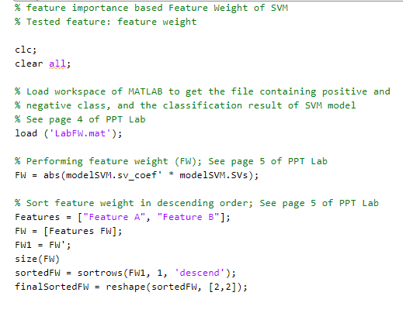

1. Load the LabFW.mat file
2. Perform feature weight. Dimension of FW is 1 * 4.
3. Then implement transpose (FW’) Dimension of FW is 4 * 1 (FW1)
4. Sort the FW with dimension 1.
5. Reshape the matrix to 2 * 2 for better readability. (Optional)

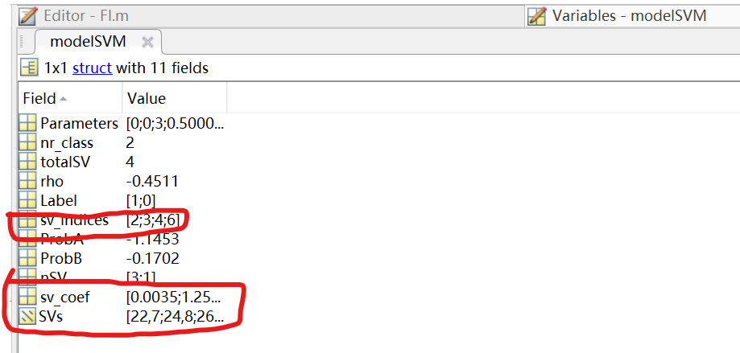

These are the important parameters used in SVM

Support Vector Coefficients. (Before Transpose)

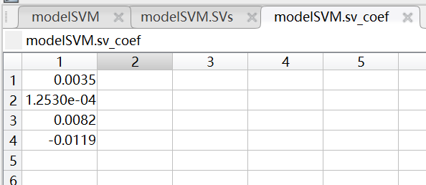

After Transpose 🡪 [0.0035, 1.2530e-04, 0.0082, -0.0119].

Detail input data of support vector.

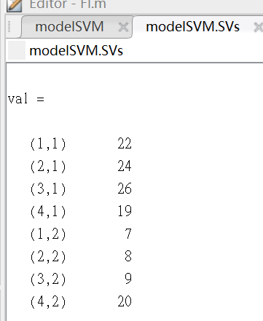

Final Result after reshape



The feature weight of feature B is 0.13797, while the feature weight of feature A is 0.068862.

Because 0.13797 > 0.068862. Therefore, feature B is selected as the most important variable.

We can only obtain the result of feature importance with SVM if we use linear kernel only.

Manual Implementation

Feature A:

W(1,1) = sv_coef1 * SV1,1 = 0.00352941176470587 * 22 = 0.07764705882

W(2,1) = sv_coef2 * SV2,1 = 0.000125304559693706 * 24 = 0.00300730943

W(3,1) = sv_coef3 * SV3,1 = 0.00823529411764707 * 26 = 0.21411764705

W(4,1) = sv_coef4 * SV4,1 = -0.0118900104420466 * 19 = -0.22591019839

Feature A score

| 0.07764705882 + 0.00300730943 + 0.21411764705 + (-0.22591019839) |

= 0.06886181691

Feature B:

W(1,2) = sv_coef1 * SV1,2 = 0.00352941176470587 * 7 = 0.02470588235

W(2,2) = sv_coef2 * SV2,2 = 0.000125304559693706 * 8 = 0.00100243647

W(3,2) = sv_coef3 * SV3,2 = 0.00823529411764707 * 9 = 0.07411764705

W(4,2) = sv_coef4 * SV4,2 = -0.0118900104420466 * 20 = -0.23780020884

Feature B score

| 0.02470588235 + 0.00100243647 + 0.07411764705 + (-0.23780020884) |

= 0.13797424297